Short-ribs

Notes 5/2020

- Made it with one pound boneless short ribs. That was enough (barely) for three people
- don't use cast iron, used all-clad
- used 1/2 the liquid, should have used it all because overreduced sauce (which was delicious)
- didn't go great with asparagus, carrots, broccoli
- careful of oven time/temp, meat overseized after 2 hours of cooking

YIELD 4 servings
TIME 2 hours 30 minutes
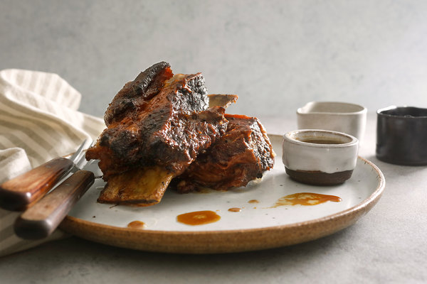

INGREDIENTS
- 3 pounds short ribs
- ½ teaspoon kosher salt
- Black pepper
- 3 tablespoons oil
- 1 cup chicken stock
- 1 cup coconut milk
- 1 cup cider vinegar
- ½ cup soy sauce
- 1 head garlic, cloves separated and peeled
- 3 bay leaves
Add to Your Grocery List

PREPARATION
- Heat the oven to 275 degrees. Season the ribs all over with salt and pepper. In a large Dutch oven over medium heat, pour in the oil. When it is warm but not smoking, add the ribs to the pan, in batches if necessary, and brown well on all sides, 4 to 6 minutes. Remove the ribs from the pan and pour out the oil.
- Add the remaining ingredients and 1 teaspoon black pepper, stir well, and add the ribs back in one layer. Use two pans if necessary, distributing the liquid. Bring to a boil over high heat. Turn off heat, cover the pan and put it into the oven. Cook until the meat is tender and falling off the bone, about 1 .5 to 2 hours. The liquid should only simmer very gently. Skim off excess fat when you check on it.
- Transfer ribs to a broiling pan. Put the braising liquid over high heat; boil for 10 to 15 minutes to thicken it. Meanwhile, put the ribs under the broiler until brown. (You can dispose of the bones if they become loosened.) Put ribs on a platter; pour sauce on them.

